Privacy & Data Policy
We do not collect any personal data from users who download or use our app.
Google, in compliance with GDPR and CCPA regulations, does not share individual user identities with developers. As a result, we cannot see who exactly downloads or uses the app.
The only data available to us is aggregate, non-identifiable analytics provided by Google Play / App Store, such as:
- App performance data – total installs, active users, and uninstalls.
- Demographic insights – age range, gender, device type, and OS version (all anonymized).
- Geographic data – country or region of installs.
- Retention reports – general usage and engagement trends.
- Ratings & reviews – only if voluntarily left by users.
This information is provided in aggregate form and cannot be used to identify individual users.
Android
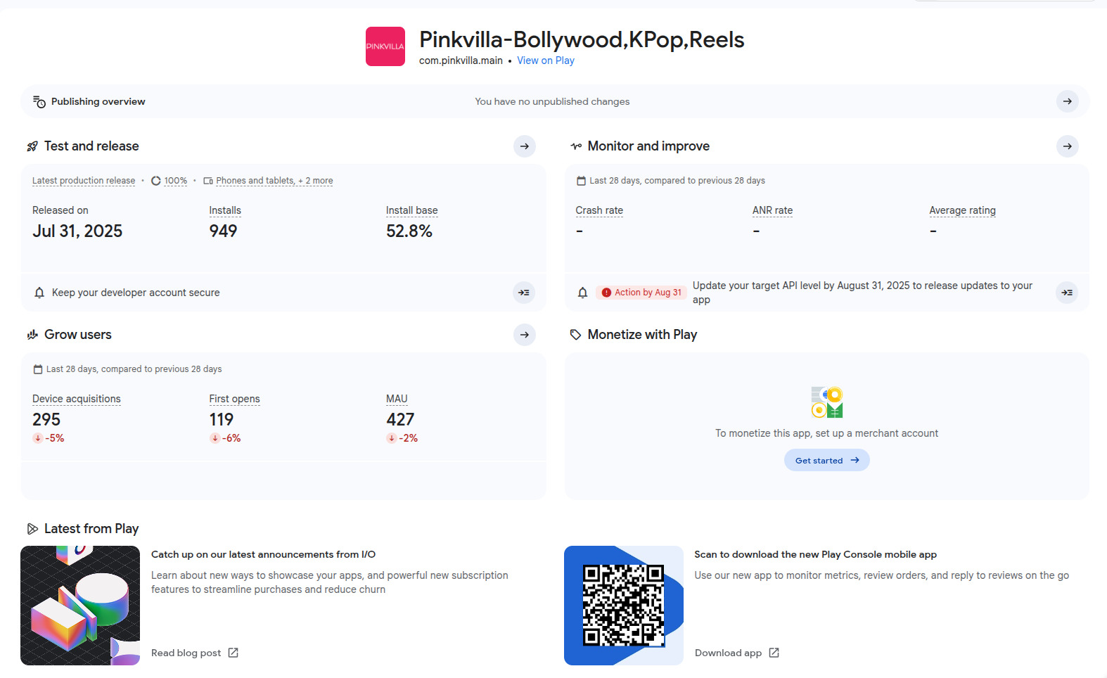
ios
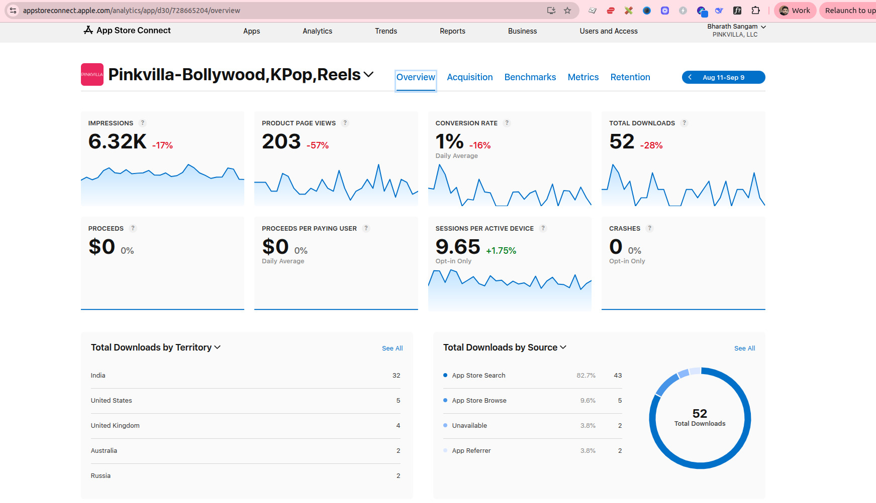

____________________________________________________________________________________
Country-wise restrictions on app downloads for new users can be enforced on both Android and iOS. However, existing users who have already downloaded the app will still be able to access and use it.
Android
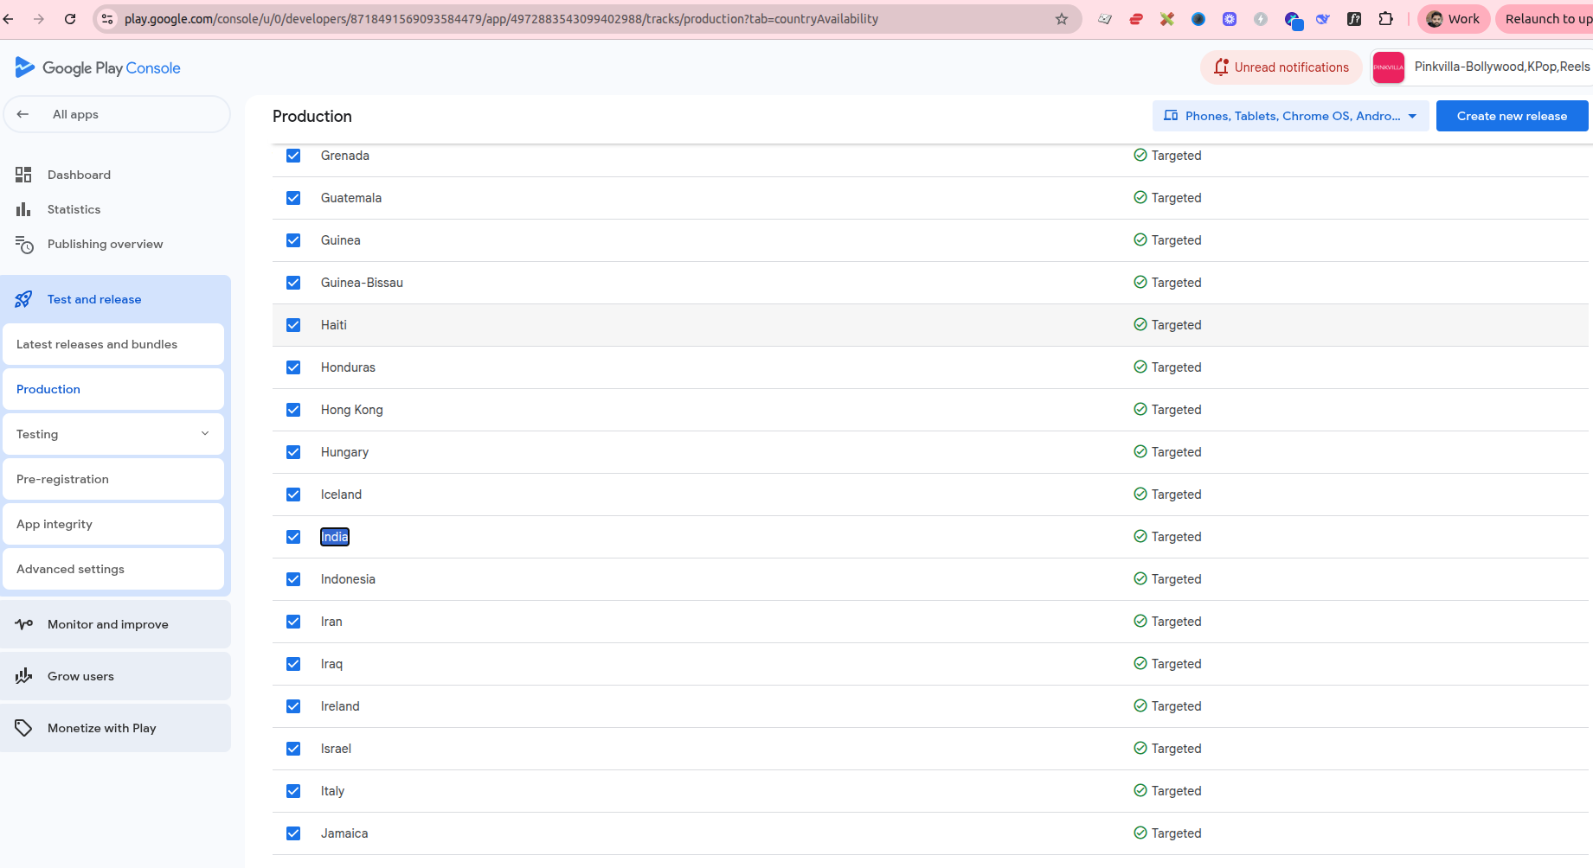

ios
